Keith Famie
Visionalist Entertainment Productions
28345 Beck Rd.
Wixom, MI 48393

Dear Keith,

On behalf of the staff and management at Hour Media, I want to tell you how excited we are to partner with you on your upcoming “Michigan – Our Vietnam Generation” project. This generation experienced a much different homecoming than their predecessors, yet their story is equally compelling and their contributions significant to the history of our country. We admire your commitment to telling their story and know that you will approach the project with the utmost passion and dedication.

We salute you on the great success of “Detroit – Our Greatest Generation” and are
proud to have been associated with you and the many, many brave vets who selflessly committed themselves to our country and the freedoms that we hold so dear. Recognizing and celebrating the history of our state and individuals like those that you featured is of the utmost importance to us and our readers.

We are looking forward to supporting this very worthwhile project.

Sincere Regards,

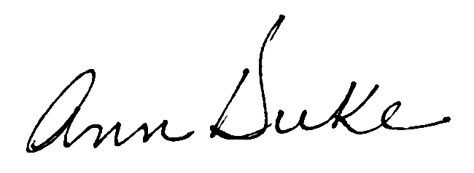

Ann Duke
Director of Advertising
Hour Media, L.L.C.

